**I**slington **C**entre for **e**nglish

student handbook 2015

don’t understand this handbook?! Ask a teacher to help!

**the school**

**1st day Information**

On your first day, arrive a little early to take a short grammar level test & a speaking/listening test with a native speaking teacher. This will help us place you in the best class for your level. We are in 2 buildings; 97 & 98 White Lion Street. The code for the front door of 98 White Lion Street is *4057*. Please see our *My first day at ICE* document for more details. If you didn’t get one when you arrived, please ask at reception or look on the first stairs in 97 White Lion Street.

MCj01965380000%5b1%5d**Any Complaints?**

We hope your experience with ICE will be an enjoyable and educational one. If you do have a complaint or any questions, there are a number of things you can do. Firstly, you can speak to your teacher. Teachers do want, like & need feedback. Secondly, if you do not wish to speak to your teacher, you may talk to your Director of Studies (Amanda). Ultimately, if you still feel that your question or complaint hasn’t been resolved, you can speak to Tim Shoben (Director) who will try his very best to help you. If you have a problem – WE WANT TO HEAR ABOUT IT!

We are sure that you will find all our staff and students to be friendly and welcoming, but if you feel that you have not been treated well, please report this to Tim or Amanda as soon as possible.

You will also have an opportunity to fill in an anonymous questionnaire in which you can express yourself freely (you don’t have to use your name). These questionnaires are available on the first staircase on the left in 97 White Lion Street.

**the classroom**

**Your teacher and your lessons**

Your teacher is there to help you improve your reading, writing, speaking, listening, pronunciation & grammar in English. If you ever need extra help, you must ask him/her. If you feel he/she is not giving you what you need he/she will be very happy to talk about it with you. Please ask! If there is something you feel your teacher can’t help you with, you can ask the Director of Studies (Amanda) for more help. For a full list of your teachers’ names, look at the Staff Picture board in reception. Your teacher will display a ‘What are we doing this week’notice in the classroom. This will tell you what the study plan for the week is and will let you know what work you have missed if you are a part-time student or have been ill or on holiday. There is also a class box that contains worksheets used in class. If you have missed a lesson, you can take one away with you to do at home. Please ask your teacher if you have any questions regarding this.

In class a percentage of reading, listening, speaking, pronunciation, vocabulary and reading is taught with the emphasis on communicative skills. This is so the needs of every student are catered for. Teaching methods vary depending on the class needs and ability but students will be presented language either directly or through a task and then practice through exercises and speaking activities. The aim of each lesson is for students to be able to produce the language taught through spoken English as well as expanding vocabulary and perfecting skills. Each class is given a set course book which is used, alongside other materials, as a guided course plan.



**Timekeeping**

Unless you have made a special arrangement with your teacher or the Director of Studies, please try to be on time for your class. It can be very disrupting for the other students and the teacher if you arrive late. If you are more than 15 minutes late, you will have to wait until the break before entering the class. This will of course affect your attendance so please be on time!

**Attendance**

It is absolutely essential that students enrolled on a full-time (minimum 15 hours per week course not including break times) for a minimum of 6 months and who have received official documentation from the school for Student Visitor or Extended Student Visitor visa achieve a **minimum of 80% attendance and must not miss 2 consecutive weeks of lessons**. These rules are set by the Home Office and are of the highest importance. Any student whose attendance drops below this figure without good reason **will be reported to the Home Office** and will not fulfil VISA requirements of stay. Please note your attendance will be calculated both BEFORE & AFTER break-times, so please don’t disappear after the breaks.

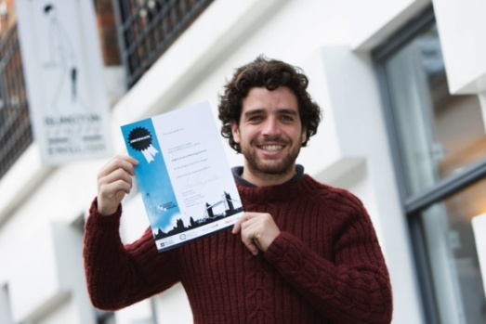

**Taking Cambridge First/ Advanced exam or IELTS?**

We highly recommend Cambridge exams. Not only are they internationally recognised by employers, they are, more importantly, an excellent means of improving your overall English. Sometimes, simply having an objective to work towards is extremely useful - even if you don’t plan to use the qualification.

During enrolment, students who want to take a Cambridge exam will be given a suggested length of course for them to learn the necessary skills and attain the correct level of English competence. If you decide to take a Cambridge exam during the course, you will have the opportunity to enrol approximately 6 weeks before the exam date. Cambridge exams require students to be available for a complete month of the exam as each exam takes place on two separate occasions that are often a number of days/weeks apart.

* **How much does it cost?**

There is an exam fee which varies from year to year and is usually in the region of £110 to £135, as well as an ICE administrative fee of £12.

* **How do we prepare?**

Students are given a ‘mock’ (practice) exam just before the time of exam entry. If a student is considered unable to pass the exam, he/she will not be entered for it. Cambridge exams are not easy and they need lots of extra hard work to be done at home! Please note that there are past paper Cambridge exams you can take out at reception. Don’t write on them, as we share them among all students. There are lots of exam practice apps to help you practice on our iPads

* **When do I get my results?**

Be patient! Normally, it takes up to 2 months for you to receive your results. To receive your results, you will be required to write down your postal address when you arrive at the exam centre.

* **Where and When do I take it?**

Cambridge KET, PET, First Certificate and Advanced exams run every March, May, June, July, August, November and December.

**The London Exam Centre**  
Tuition House  
27 St George's Road  
London SW19 4EU

ICE organises exams through this centre:

**Cancellations & refunds for courses**

For students who have not started their course or who are in their first week of study, a refund is available minus a £100 administration fee. In exceptional circumstances, if a student wishes to cancel a course after the 1st week, a refund equivalent to the value of the remainder of the course can be given at the discretion of the management. If accommodation has been booked and cancelled, your booking fee is not refundable.

In the event of a VISA refusal, a refund is given minus a £100 administration fee on receipt of an original VISA refusal letter. Full cancellations and refunds policy can be found on the back of your enrolment form.

**Violent or Abusive behaviour policy**

Abusive behaviour of any kind will never be accepted in our school. If a students is found be have been physically or verbally abusing a teacher or another student, ICE reserves the right to expel the offending student without a refund of course fees. Our procedure for this is as follows: the student has a documented meeting with Director of Studies or Director to discuss the matter. If an improvement in behaviour is not seen and the student continues to be disruptive, the student will be asked to have a second meeting in which the student has this final chance to improve his/her behaviour. If this does not happen, the student will be informed at the 3rd meeting that he/she must leave the school.

**Student facilities**

MCj03979970000%5b1%5d

**DVD library**

We have a library of DVD films that are free for all enrolled students. Your name, course and the title of the film must be recorded by Sylvia, our school receptionist.

**Graded reader books** This collection is also free to use. They are ‘graded’ to allow you to take out the correct level book for your English ability and many have comprehension questions to help readers fully understand and ‘get into’ the text. If you feel you would like extra reading homework, please consider taking one out. To do so, you must leave your name and book title with Magdalena

**Native English books** In the Quiet Study room on the 1st floor of 98 White Lion Street, you can find a collection of around 500 books written in English that you can take out at reception.

**Exam library** We recycle exams: KET, PET, FCE, CAE & IELTS. Take one for practice for 2 days and mark it yourself. Please don’t write on it as others want to use it, too!

**Please note**: A fine of 20p per day for late books, DVDs or exams will apply which goes to Sobell Hospice charity. (Remember, you can always contribute to this charity if you haven’t taken anything out!!)



**iPads**

There are many excellent apps to practice your English in the Testing Zone, 2nd floor no.97 and in the Quiet Study room 1st floor no.98. There are headphones to practice your listening, too.



The code is available from reception for Wi-Fi access & is free for all students.

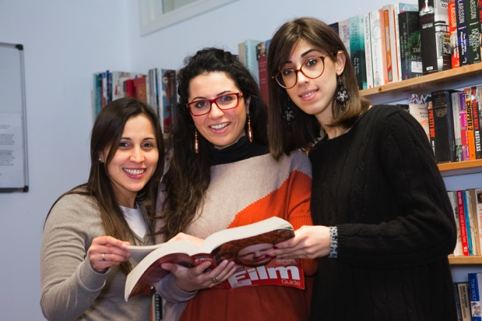

**Quiet Study/Book Room**

This can be found on the 1st floor of 98 White Lion Street. You will also find a collection of around 500 books written in English that you can take out at reception. There are also other classrooms available for quiet study. Please see the room availability chart on the noticeboards in the stairwells or ask at reception. Students can also take out specially selected magazines to help them with their IELTS exam Reading paper, such as New Scientist or National Geographic.



**Next Stop … University in the UK?**

In the Quiet study room, there is a collection of publications about further study options in the UK. If you are thinking about going onto a University degree after your course at ICE, you can discuss this with Tim, our Director. ICE has links with a number of London-based Universities and we can help you with your enrolment and organise an introduction to a member of the University staff for you.

**Where to relax?**

The Testing Zone in no.97 is available from 9am for students to use the PCs. At break times, you can buy coffee from the student zone, play table football or ping pong and relax on the sofas.

**Other Courses & Services**

**Language Workshops for Extra Practice**

Try our one-hour and fifteen minute workshops on a specific area you want to practise.

ielts%20logo**IELTS Exam preparation Course –** Get the IELTS score you need on our IELTS exam preparation course. This runs every morning and Monday/Wednesday evenings from 6.30 to 8.30pm.

**Essential Grammar books**are on sale at reception.

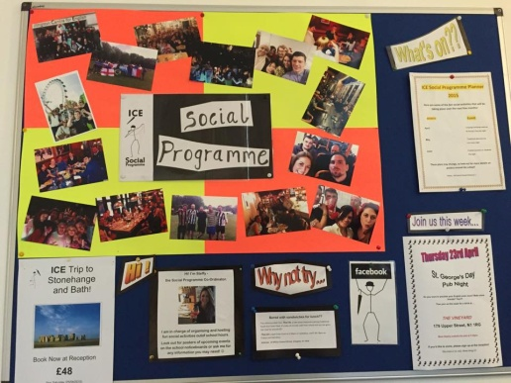

**Notice boards and other useful information**

These are here to give you useful and up-to-date information on accommodation and ‘What’s On?’ in and around Islington. There will be info on bands, nights out, clubs and student offers. You can find these boards in the common areas and along the walls of the staircase. Also, have a look at our Islington Local Information folder for ideas on things to do in one of London’s most vibrant areas.

**Social Programme**

Our social programme runs every two weeks and every week in summer between June & August. For full information, please see the ‘What’s on?’ board. Past events include; a trip to The Kings Head Theatre, pub quiz, fireworks night, Sangria night, trips to the local cinema and karaoke. We try to keep the activities local as most of our students live nearby and Islington is a fantastic place to go out. If you have any suggestions for future social evenings, our teachers would be very happy to hear them. If you have any questions, ask Steffy, our Social Programme Coordinator.

**ICE Facebook Site**

Get registered and join the ISLINGTON CENTRE FOR ENGLISH group. Meet other students and teachers there and get news about upcoming events at the school. Be part of the worldwide ICE community!

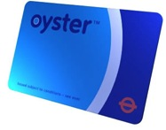**TFL Oyster Card Discount**

Students who are enrolled on a full-time study course (15 hours a week) for at least 14 weeks are entitled to a discount from Transport for London. Please ask at reception for details about how to apply. You must show good attendance if you wish to use this card.

**Want a Bank letter, Enrolment Letter, Certificate?**

On your right-hand side as you walk up the stairs in no.97, you will find a ‘Document Request Form’. Fill this in. It can take up to 48 hours to get your document.

**Accommodation at ICE**

At ICE, we offer:

1. **East London House share**
2. **Student Halls accommodation** in University halls of residence (from early June to the end of August.)
3. **Homestay** accommodation with a family

**1. Low-priced House Share**

If you are looking for one of the cheapest ways to get started in London and to have lots of fun sharing a house with international students, this is it! Travel into ICE is easy with good links on buses and the Central line underground. A landlady pays weekly visits to the houses to ensure satisfaction all-round.

**2. Student Accommodation or ‘University Halls’**

Stay with other overseas students, in a secure environment, sharing kitchen/dining and shower facilities. Student halls are a really great way to share your London experience with others just like you. ICE offers some high quality ‘student halls’ throughout the summer months (June to August inclusive) within easy reach of your English classes. Students will have single or double rooms with or without ensuite. Many halls have wi-fi access – please ask before you arrive if you are interested in this – and most have internet access that you can pay for.

#### 3. Homestay

All the homestay families used by ICE have been carefully selected, inspected and visited regularly, in accordance with British Council regulations by our accommodation agency. We charge an accommodation fee of £35 per booking, but we are also very happy to provide you with the contact information of our accommodation agency and you can book it yourself (and save on the booking fee, of course!).

Staying with an English-speaking family will be an important part of your visit and we – and our families – want to make it a success. Of course, you are likely to find the environment and lifestyle different from what you are used to.

For more information and a full price list, please ask Olivia at reception.  The ICE Marking Code

Teachers at ICE mark your written work using a ‘marking code’. This enables students to discover the correct answer for themselves. The symbols can be seen below:

**WW** – Wrong word

**WO** – Word order

**P** – Punctuation

**Gr** – Grammar

**Sp** – Spelling

**T** – Tense

**R** – Register

**VF** – Verb Form

**?** – What do you mean by…?

**^** - Missing word

* **Remember!** After making your corrections, you must go back to your teacher and check.